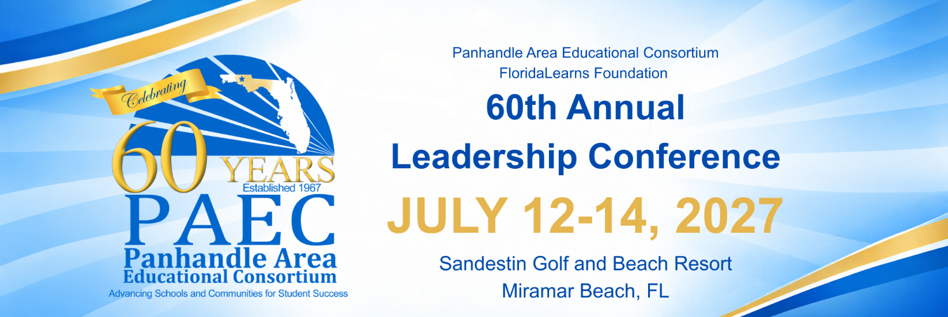
Conference Partner Registration
Name of Company:
Address:
City: | State: | ZIP:
Name of Contact:
Title:
Phone Number:
Email Address:

Please select the available Partnership Opportunities below:

 | Diamond Package | $10,000
 | VIP Package | $6,500
 | Gold Package | $5,000
 | Silver Package | $2,500

Add-Ons
 | Reception Partner | $2,000
 | LATE FEE (After May 31, 2025) | $150
 | TOTAL DUE

*IMPORTANT: THIS REGISTRATION SERVES AS YOUR INVOICE*

Please use one of the methods below to secure your registration. Exhibit table assignments will not be made until all registration materials and payments have been received.

*A $150 LATE FEE WILL BE APPLIED TO INVOICE AFTER MAY 31, 2027*

Pay by Check | Pay by Credit Card
Make checks payable to:  FloridaLearns Foundation  Mail check and registration forms to:  FloridaLearns Foundation  Attn: Charles Walker  P.O. Box 243  Chipley, FL 32428 | Go to: https://www.paec.org/wp/instructional/leadership-conference/conference-partners-registration-and-payment/  Email registration forms to:  Charles Walker  Partnership Coordinator  Email: charles.walker@paec.org

*IMPORTANT INFORMATION*
- MAY 31, 2027:
  - PAYMENTS DUE
  - Deadline to ensure you receive all the appropriate recognition in conference programming.
  - Company artwork, videos and logos must be in pdf, eps, tif, gif, or ai format AND sent to Charles Walker (charles.walker@paec.org)
- DOOR PRIZE AND PARTICIPANT BAG:
  - Option to include materials in conference bag if materials are received by July 1, 2027.
  - All partners should bring a door prize. Partners will receive recognition for door prizes that will be drawn at the end of the conference.
Conference Partnership Coordinator
Charles Walker
850-328-4131
charles.walker@paec.org

